College of Arts and Sciences

186 University Hall
230 North Oval Mall
Columbus, OH 43210

Phone (614) 292-1667
Fax (614) 292-8666
Web artsandsciences.osu.edu

15 November 2010

Lawrence Krissek, Professor of Earth Sciences
Faculty Chair, Committee on Curriculum and Instruction
College of the Arts and Sciences

Dear Larry,

The Subcommittee of the Arts and Humanities 2—Humanities Intensive of the College of Arts and Sciences met and reviewed proposals on Monday, November 15, 2010. The committee unanimously endorsed two proposed revisions for the BA in Music and the BM in Composition in Music (a tagged degree). We are asking that you expedite these proposals through the curricular review process at ASC CCI and to CAA. The revisions are for the quarter versions of our BA in Music and BM in Composition programs.

The subcommittee recognized the fact that two of the fourteen undergraduate majors in the School of Music did not pass accreditation for its students under their current format. The School of Music is proposing to address the issues with the BA in Music by adding 6 credit hours to the music major coursework of the 181 credit hour BA. The addition of the credit hours affects a small number of students; the School of Music has identified twenty-seven students who will benefit from an increased applied study. The subcommittee supported this addition because it is for those students coming in under quarters and for a relatively small number of students. For the BM in Music Composition, the School of Music is proposing to address the issues of the perceived need of more composition experiences by re-arranging the course work they already have in place and by replacing electives in music with compositional experiences for their three students in the BM in Music Composition. The subcommittee supported this addition because it, also, is for those students coming in under quarters and is a very small number of students.

The change in curricular offerings, if approved during this academic year, will allow us to submit the curricular changes to the National Association of Schools of Music and be re-accredited by the national accrediting organization for another ten years.

If you have any questions or concerns, please do not hesitate to call or email me at 292-5727 or williams.1415@osu.edu.

Thank you for your consideration and fast-tracking of these proposals,
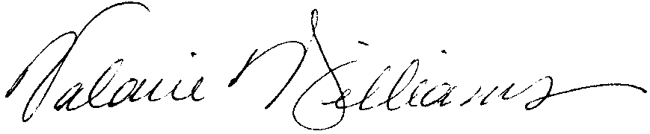
Valarie Williams, Chair-for-a-Day of Arts and Humanities Subcommittee 2—Humanities Intensive
Professor of Dance and Associate Dean, College of Arts and Sciences, Arts and Humanities

CC: Mark Shanda, Interim Divisional Dean, Arts and Humanities and Professor of Theatre
Timothy Leasure, Associate Director of the School of Music and Associate Professor of Music
Rick Blatti, Interim Director of the School of Music and Professor of Music

